MEASUREMENT OF THE READINESS COMPONENT OF GAINTM –
A SUMMARY

The Readiness Axis seeks to measure the ability of a country’s private and public sectors to absorb additional investment resources and apply them effectively towards increasing resiliency to climate change. This focus is similar in spirit to the World Bank’s Country Policy and Institutional Assessment (CPIA) measurements, which determine development assistance for low income countries. The assistance is based on performance in implementing policies that promote economic growth and poverty reduction.
The readiness concept targets those portions of the economy, governance and society that affect the speed and efficiency of absorption and implementation. It attempts to capture for each of these three components how well the prevailing environment facilitates adjustment to change.
For example, if the private sector can easily and quickly set up new businesses, access new capital, refocus as conditions change and obtain resources from other countries, that private sector will be more ready than the private sectors of other countries that continue to experience considerable hurdles to business creation, such as securing credit, changing the nature of products, or moving resources across the border. If resources are brought into a country with rampant bribery and a weak rule of law, chances are good that they will be less efficiently used than in a country where none are skimmed off the top and agreements are dependable. If residents can readily plan how to organize the new resources and collaborate with people in other parts of the country or world, the outcome will be better than in countries where people have little experience organizing, do not understand the potential of the resources and have no way to consult with others elsewhere on implementation.
Readiness also represents aspects of adaptive capacity that can be influenced relatively quickly. If businesses do not face severe barriers, restrictions or monopolies, they can more easily adjust to the new demands on the size, scope or focus of their endeavors. If the rule of law is lax, governments can make changes to enhance reliability. Improving a farmer’s warning of weather emergencies can sometimes be as simple as buying a mobile phone.

SELECTING THE INDEX

Unlike for the vulnerability axis, there is a fairly short list of closely applicable candidates for Economic, Governance or Social Readiness.
The two chief candidates for the Economy component are The Doing Business Index (World Bank) and The Index of Economic Freedom (The Heritage Foundation/The Wall Street Journal), and its subcomponents. Each is widely circulated and used. There are also some lesser known indices like the Economic Freedom of the World (Fraser Institute/CATO Foundation).
Candidates for the Governance component include the World Governance Index (World Bank) and the Failed States Index (The Fund for Peace). Moreover, each of the various overall indices has sub-indices that may by themselves add to the measure of readiness.
Social readiness focuses on two important aspects: Human capital and mobile communcations. Human capital measures the availability of a highly educated workforce The greater the percentage of highly educated people, the more likely potential problems will be anticipated, prevention and/or emergency plans will be drawn up, and people will be mobilized in a timely fashion. Mobile communications continue to develop applications that enable citizens to accomplish tasks more easily and conveniently (e.g. electronic transactions, mobile banking, finding destinations). In emergencies mobile phones can assist in more effectively organizing warnings and relief efforts (enhancing coordination of efforts, providing health care in remote areas, quickly identifying locations most in need, enforcing transparency, creating and accessing valuable information).
Selecting the various indices and subcomponents was based on these criteria:
- A minimal set of indicators should produce a relevant score to measure whether the country will be able to successfully implement adaptation projects.
- As many (UN) countries as possible should be included.
- As many years as possible should be included, ideally 1995-2011. A useful time series allows the construct of readiness changes, enhancing the goal of tracking the trajectory within countries.
- Indicators should be as credible as possible.
- Data should be as generally available as possible (preferably publicly available) so that others could reproduce the results.
- Scores should point to actionable improvements.

Table 1 illustrates part of the process. This table provides the correlations (R-squares) among the overall and sub-indices of the Failed States Index (FSI), the World Governance Index (WGI), the Doing Business Index (DBI) and the Index of Economic Freedom (IEF), plus the ratio of the enrollment in tertiary education (regardless of age) to the population of the age group that officially corresponds to tertiary education and the number of mobile phones per 100 people. Each variable uses the most recent data available.
Immediately it is clear that information contained in one indicator is often captured by others. The Failed States Index for instance turns out to be very similar in their definitions and correlations to components of the World Governance Indicators (correlations up to 0.6-0.8) and components of the Index of Economic Freedom (0.5-0.8).

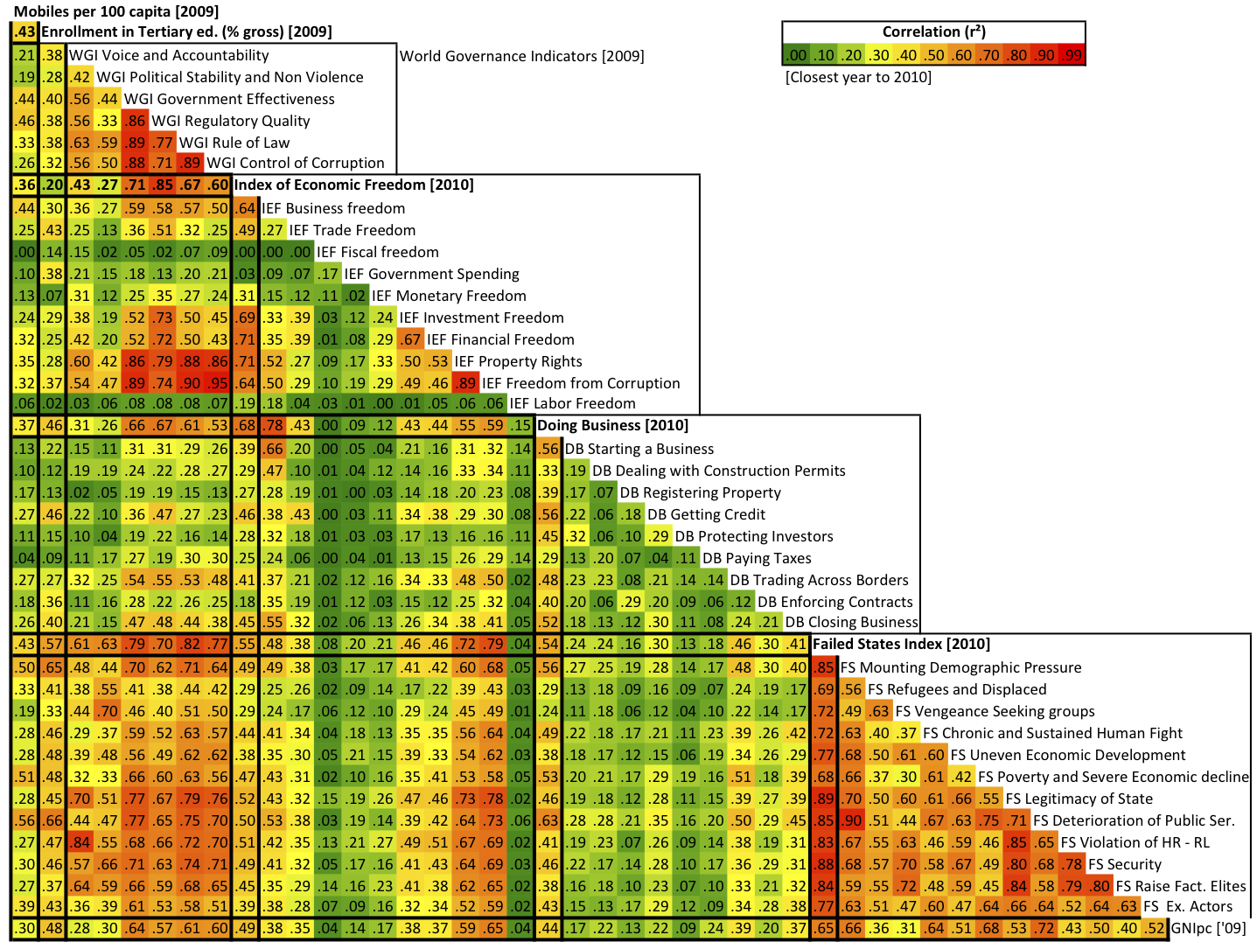
TABLE 1
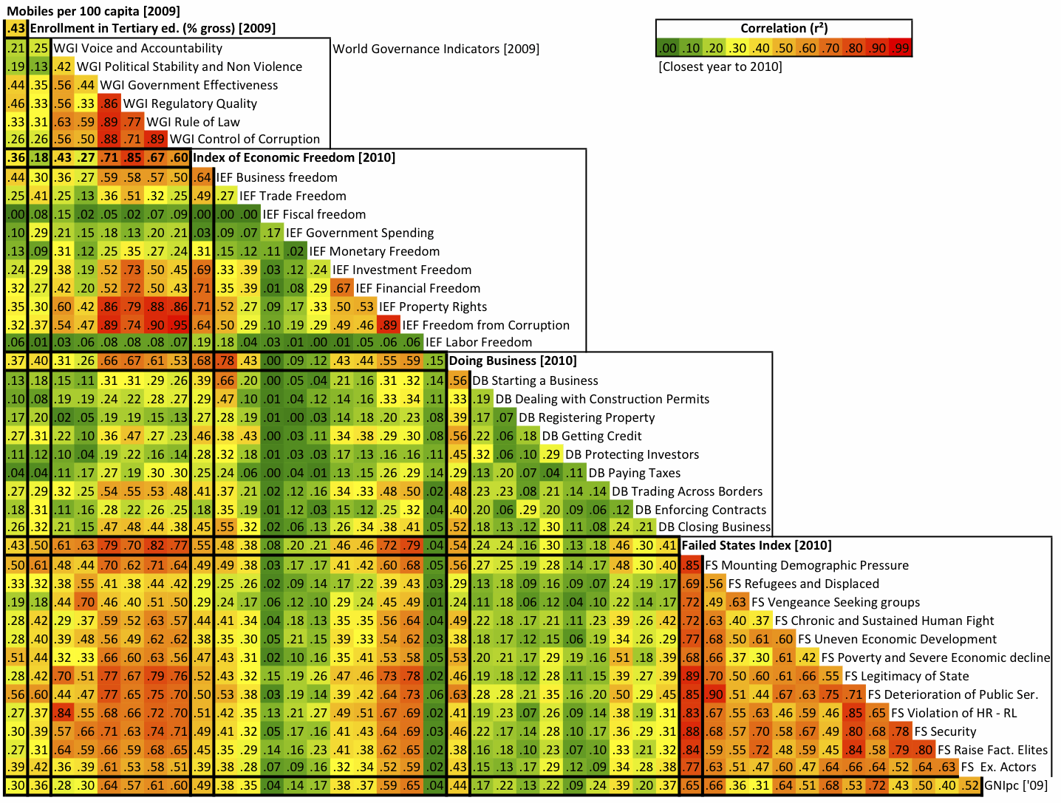
Correlations Among Potential Readiness Indices and Their Subcomponents

Some of the Doing Business (DB) components are not strongly correlated with other candidates, but the overall index is correlated with at least three components of the World Governance Index. It is also highly correlated with the overall IEF (0.7) and its Business Freedom component (0.8). These high correlations are not surprising. DB consists of many measures of ease of business as well as some approximating rule of law. An important drawback of DB is that only two years of overall scores are available (though there are raw scores for each of its subcomponents back to 1995).
Limitations for the World Governance Indicators are also immediately apparent. Four of the six components are highly correlated with each other (as high as 0.92). Clearly there is overlap of information in these components. Moreover the IEF captures most of the information of these four overlapping components of WGI. The source of the high correlation is not surprising in half the cases. The Regulatory Quality and Rule of Law (RQ and RL) components of WGI explicitly use the IEF as a data source (1 of 8 sources for RQ and roughly 1 of 14 sources for RL).
Therefore it does not make sense to include all six WGI components, only the two exceptions ("Voice and Accountability" plus "Political Stability and Non-Violence") that are significantly correlated neither to other WGI components nor to the overall IEF. These two exceptions can add to the overall information.
The Index of Economic Freedom closely follows the six criteria listed above. It is one of the most complete in the number of years and countries and is readily available (both for data and methodology). It spans not only the economy component (employing some parts of Doing Business such as number of days to start a business), but also much of the government component such as rule of law and corruption. No wonder that correlations with the IEF seem to capture much of what other variables target. It is also directly actionable. A country with a low readiness score might find that it could improve its score by making it easier to start a business, by reducing corruption or increasing the independence of judges, or by allowing a freer flow of capital from the domestic or foreign financial markets.
In addition there is statistical evidence that changes in IEF scores relate to the growth rates of countries (Figure 1). Changes in IEF scores are computed over a 10 year period (2000 – 2010) and ranked from the country with the biggest improvement in score to the one with the biggest decline. The ranking is divided into quintiles. Within each quintile the average growth rate of all countries (contained in that quintile) is computed. Those averages are the numbers shown above each quintile bar in Figure 1. Clearly, the average growth rate for countries that had the biggest improvement (4.2 percent) is significantly larger than in the remaining four quintiles (2.3-3.2 percent). Also the average growth rates for the next two quintiles(3.1 and 3.2 percent) are larger than those in the bottom two (2.3 and 2.6 percent). The implication is that those countries improving their scores the most tend to have higher growth rates.

Figure 1
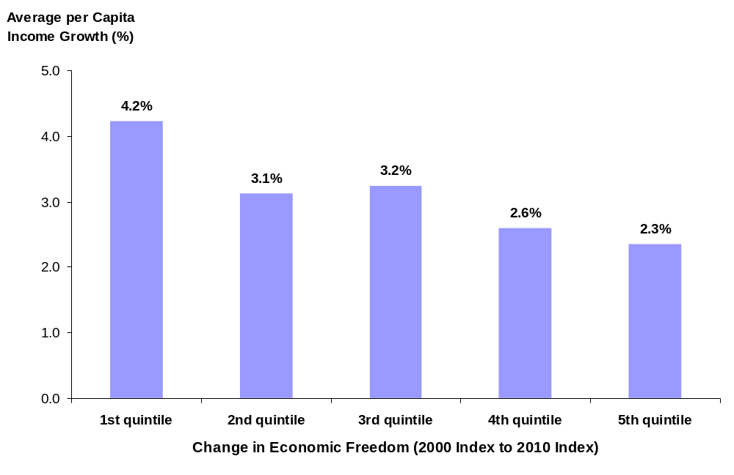
Both of the society indicators are far less correlated to other variables (Table 1). For the number of mobile phones per 100 people, the correlations range from 0.00 (IEF Fiscal Freedom) to 0.56 (Failed States Deterioration of Public Services). For the tertiary school enrollment the correlations range from 0.1 (IEF Labor Freedom) to 0.61 (Failed States Mounting Demographic Pressure).
After considering various combinations of the variables and finding dead ends, the final GaInTM version 1.0 of the Readiness Axis is captured with the combination consistent with Table 1 results – Five variables: The IEF, two components from WGI (Voice and Accountability and Political Stability and Non Violence) and the two society indicators.
It should be noted that while the tertiary school enrollment satisfies most of the criteria laid out, it does create a problem with the number of countries covered. Only 174 of the possible 192 countries report data, limiting the number of countries on the Readiness Axis to the lower figure of 159. More extensive coverage of readiness is desired, but we have been unable to find as good a measure of advanced human capital that also has better coverage of years and countries.
Subsequent versions may consider additional potential variables, and we encourage suggestions of other candidates. Their relevance, however, will be determined in the same manner.

Weighting the Five Variables and Creating the Readiness Axis
The Readiness Axis is created through a relatively simple process. The values of each of the five variables are normalized between 0 and 1 by dividing each country’s number in the series by the maximum value found among the countries. The scores are then appropriately weighted and aggregated. Rankings are based on the aggregate score.
The weightings are divided among the three components of readiness (economy, governance, society) as follows:
Economic Readiness – 50 percent
Governance Readiness – 25 percent
Social Readiness – 25 percent

The Index of Economic Freedom, the lone Economic Readiness indicator, receives a disproportional weighting because it has much more information than the other four. As seen in Table 1, the IEF is an aggregate of 10 separate factors ranging across such issues as international trade, financial markets, business, labor, corruption and property rights. By contrast there are only two fairly specific indicators in the both the Governance and Social components. Each of those four indicators receives 12.5 percent weights.

Lacking an objective guide to weighting, the values are estimates. We welcome comments and suggestions of how to improve the weighting system.
Mobile phones and tertiary education have one additional step in the aggregate score process. For example, it is assumed that once the number of mobile phones per 100 reaches a certain level, that measure of Social Readiness is saturated. In other words, while an additional phone per 100 people may add to the readiness when the number is 25, at some point enough phones exist that another makes little impact. Clearly where there are 150 phones per 100 people, raising the number to 151 adds little to preparation. It is assumed that the point of saturation is 90 (though it may well be below that level). All countries where the number of phones is 90 or above receive the maximum standardized value of 1.
A similar cap is applied to the proportion of population in tertiary education. A high level of human capital increases the ability to effectively absorb resources, but as that level rises increasing less is gained from additional advanced degrees. For this indicator the limit is assumed reached when 70 percent of the relevant age group is reported to be enrolled in tertiary education.

WHAT THE READINESS AXIS TELLS US
The complete country readiness ranking is found in ANNEX 1. Not surprisingly the rankings are highly correlated to the wealth of the country. Table 2a and 2b illustrate this point for the top 10 and bottom 10 countries on the Readiness Axis. The top-ranked countries are highly developed, and the bottom is dominated by some of the poorest of the poor countries.

Table 2a
Top 10 Countries

1 | New Zealand | 0.86
2 | Australia | 0.85
3 | Denmark | 0.84
4 | Finland | 0.83
5 | Switzerland | 0.83
6 | Ireland | 0.82
7 | United States | 0.81
8 | Sweden | 0.81
9 | Canada | 0.81
10 | Norway | 0.81

Table 2b
Bottom 10 Countries

149 | Nepal | 0.37
150 | Cuba | 0.35
151 | Yemen | 0.35
152 | Comoros | 0.35
153 | Burundi | 0.34
154 | Ethiopia | 0.32
155 | Chad | 0.31
156 | Central African Republic | 0.31
157 | Congo, Dem. Rep. of the | 0.27
158 | Eritrea | 0.24
159 | Zimbabwe | 0.20

A scatterplot of the Readiness Scores and the log of Gross Domestic Income per capita (GDPpc) (Figure 2) confirm this relationship. There is a very high correlation (0.73) between the Readiness score and level of income per capita. However, the plot also reveals that there are important differences among countries even with similar levels of income. If we consider the trend line as the global relation between readiness and income per capita, countries above the trend line have more readiness than their income levels would indicate. These are the countries that may be attractive to private investors. In contrast the countries below the trend line have less readiness than anticipated and are far less attractive for investment.

FIGURE 2
Readiness Score Versus Income Per Capita

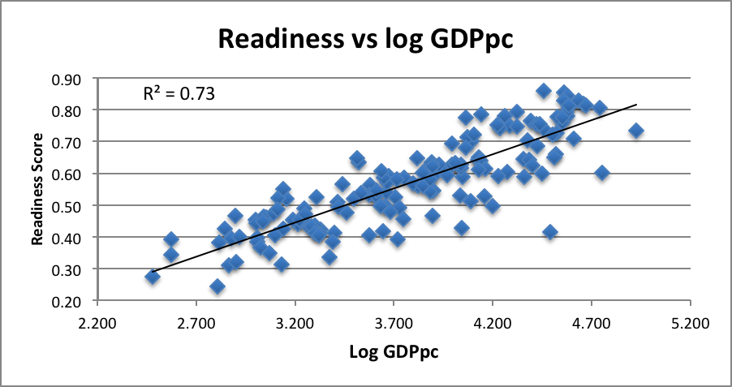

ANNEX 1 – The Current Readiness Rankings of Countries

1 | New Zealand | 0.86
2 | Australia | 0.85
3 | Denmark | 0.84
4 | Finland | 0.83
5 | Switzerland | 0.83
6 | Ireland | 0.82
7 | United States | 0.81
8 | Sweden | 0.81
9 | Canada | 0.81
10 | Norway | 0.81
11 | Netherlands | 0.81
12 | Iceland | 0.79
13 | Estonia | 0.79
14 | Chile | 0.78
15 | Austria | 0.78
16 | Lithuania | 0.78
17 | Belgium | 0.78
18 | Japan | 0.78
19 | United Kingdom | 0.78
20 | Uruguay | 0.78
21 | Czech Republic | 0.77
22 | Spain | 0.76
23 | Germany | 0.76
24 | Korea, Republic of | 0.76
25 | Slovenia | 0.75
26 | Poland | 0.75
27 | Hungary | 0.75
28 | Slovakia | 0.75
29 | Latvia | 0.74
30 | Cyprus | 0.74
31 | Portugal | 0.74
32 | Luxembourg | 0.73
33 | France | 0.73
34 | Italy | 0.72
35 | Romania | 0.72
36 | Mauritius | 0.71
37 | Greece | 0.71
38 | Malta | 0.70
39 | Bulgaria | 0.70
40 | Saint Lucia | 0.69
41 | Israel | 0.69
42 | Croatia | 0.68
43 | Panama | 0.68
44 | Armenia | 0.67
45 | Bahrain | 0.66
46 | Macedonia | 0.66
47 | United Arab Emirates | 0.65
48 | Botswana | 0.65
49 | El Salvador | 0.65
50 | Mongolia | 0.65
51 | Jordan | 0.64
52 | Oman | 0.64
53 | Argentina | 0.64
54 | Malaysia | 0.64
55 | Jamaica | 0.64
56 | Cape Verde | 0.63
57 | Serbia | 0.63
58 | Peru | 0.63
59 | Qatar | 0.63
60 | Kazakhstan | 0.63
61 | Brazil | 0.63
62 | Dominica | 0.63
63 | Trinidad and Tobago | 0.62
64 | Thailand | 0.62
65 | Dominican Republic | 0.62
66 | Costa Rica | 0.62
67 | Colombia | 0.62
68 | Mexico | 0.61
69 | Albania | 0.61
70 | Turkey | 0.61
71 | Samoa | 0.61
72 | Kyrgyzstan | 0.61
73 | Ukraine | 0.60
74 | Georgia | 0.59
75 | Russian Federation | 0.59
76 | Bosnia and Herzegovina | 0.59
77 | Saudi Arabia | 0.59
78 | Belarus | 0.59
79 | Paraguay | 0.59
80 | Tunisia | 0.58
81 | Guatemala | 0.57
82 | Namibia | 0.57
83 | Moldova, Republic of | 0.57
84 | Honduras | 0.56
85 | Belize | 0.56
86 | Suriname | 0.56
87 | Ghana | 0.55
88 | Vanuatu | 0.55
89 | Azerbaijan | 0.54
90 | Ecuador | 0.54
91 | Fiji | 0.54
92 | Philippines | 0.54
93 | Indonesia | 0.53
94 | Morocco | 0.53
95 | Lebanon | 0.53
96 | Bolivia, Plurinational State of | 0.53
97 | Gabon | 0.53
98 | Egypt | 0.52
99 | Gambia | 0.52
100 | Benin | 0.52
101 | Micronesia, Federated States of | 0.52
102 | Algeria | 0.51
103 | Venezuela, Bolivarian Republic of | 0.51
104 | Nicaragua | 0.51
105 | Tonga | 0.50
106 | Bhutan | 0.50
107 | Libyan Arab Jamahiriya | 0.50
108 | Viet Nam | 0.49
109 | Maldives | 0.49
110 | Senegal | 0.49
111 | Zambia | 0.49
112 | Swaziland | 0.48
113 | India | 0.48
114 | Tanzania, United Republic of | 0.47
115 | Tajikistan | 0.47
116 | Mozambique | 0.46
117 | Mali | 0.46
118 | Burkina Faso | 0.46
119 | China | 0.46
120 | Madagascar | 0.45
121 | Kenya | 0.45
122 | Sao Tome and Principe | 0.45
123 | Cambodia | 0.45
124 | Uganda | 0.45
125 | Rwanda | 0.44
126 | Côte d'Ivoire | 0.44
127 | Lao People's Democratic Republic | 0.44
128 | Mauritania | 0.43
129 | Iran, Islamic Republic of | 0.43
130 | Nigeria | 0.43
131 | Malawi | 0.43
132 | Lesotho | 0.43
133 | Cameroon | 0.42
134 | Syrian Arab Republic | 0.42
135 | Equatorial Guinea | 0.42
136 | Pakistan | 0.41
137 | Djibouti | 0.41
138 | Bangladesh | 0.41
139 | Papua New Guinea | 0.40
140 | Congo | 0.40
141 | Togo | 0.40
142 | Guinea | 0.40
143 | Sierra Leone | 0.39
144 | Liberia | 0.39
145 | Angola | 0.39
146 | Guinea-Bissau | 0.38
147 | Uzbekistan | 0.38
148 | Niger | 0.38
149 | Nepal | 0.37
150 | Cuba | 0.35
151 | Yemen | 0.35
152 | Comoros | 0.35
153 | Burundi | 0.34
154 | Ethiopia | 0.32
155 | Chad | 0.31
156 | Central African Republic | 0.31
157 | Congo, the Dem. Rep. | 0.27
158 | Eritrea | 0.24
159 | Zimbabwe | 0.20

School enrollment, tertiary (percentage of gross). Gross enrollment ratio is the ratio of total enrollment, regardless of age, to the population of the age group that officially corresponds to the level of education shown. Tertiary education, whether or not to an advanced research qualification, normally requires, as a minimum condition of admission, the successful completion of education at the secondary level. Source: Word Development Indicators (WB) using data originated United Nations Educational, Scientific, and Cultural Organization (UNESCO) Institute for Statistics.
Mobile cellular telephone subscriptions are subscriptions to a public mobile telephone service using cellular technology, which provide access to the public switched telephone network. Post-paid and prepaid subscriptions are included. Source: International Telecommunication Union, World Telecommunication/ICT Development Report and database, and World Bank estimates.
Courtesy of The Heritage Foundation. An earlier version of this graph was published in the 2006 Index of Economic Freedom, page 3, Figure 2. The correlation of the data is 0.23.

